**Weather Trends Project**

**Getting Data from DB:**

* SQL Query used to find the cities listed in my country "Egypt"
  + SELECT city FROM city_list WHERE country='Egypt';
  + Result only Cairo & Alex are the listed 2 cities in Egypt



* SQL Query used to get temperature for Cairo, Egypt
  + select * from city_data where country = 'Egypt' and city = 'Cairo' order by year asc;
  + Total of 206 temp. record in DB (from 1808 till 2013)

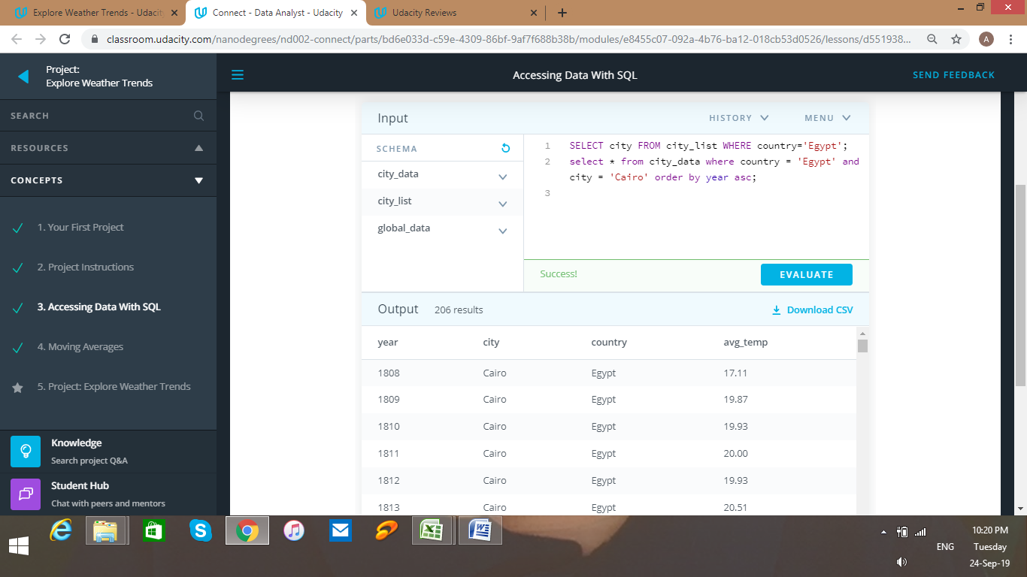

* SQL Query used to get global temperature in same period of time
  + select * from global_data where year >= 1808 and year <= 2013;

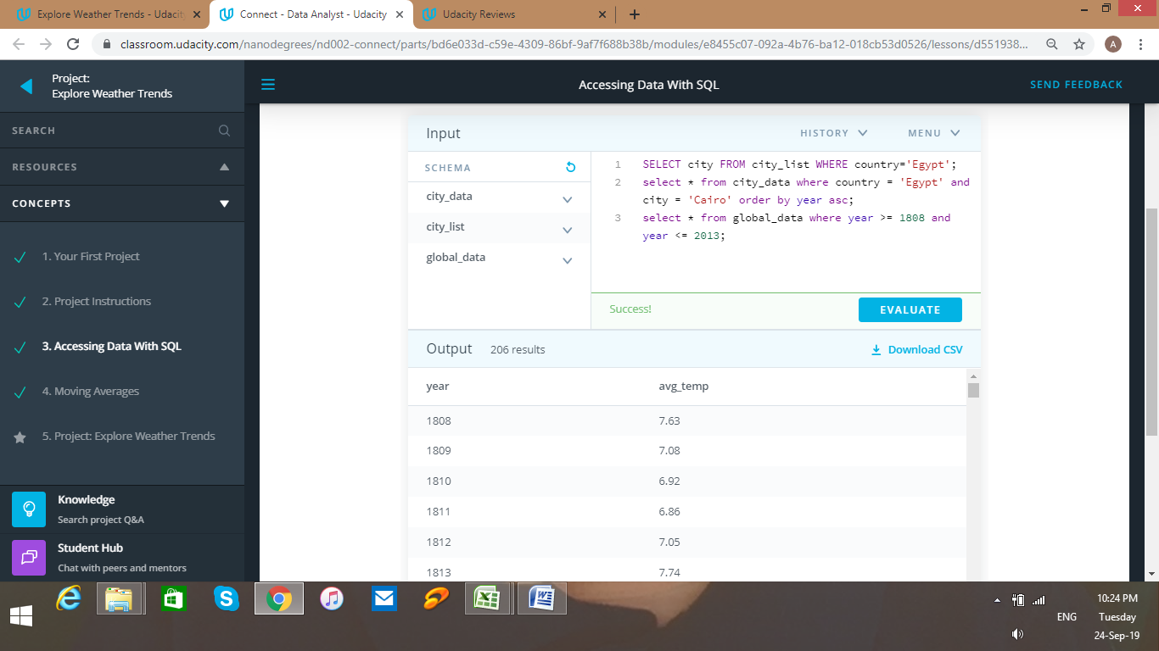

**Data Processing Using Excel:**

* Cairo Temperature data was saved to excel file and moving average was calculated over 10 years
* Vlookup excel function used to get the global temperature record for the same year and moving average was calculated over 10 years.

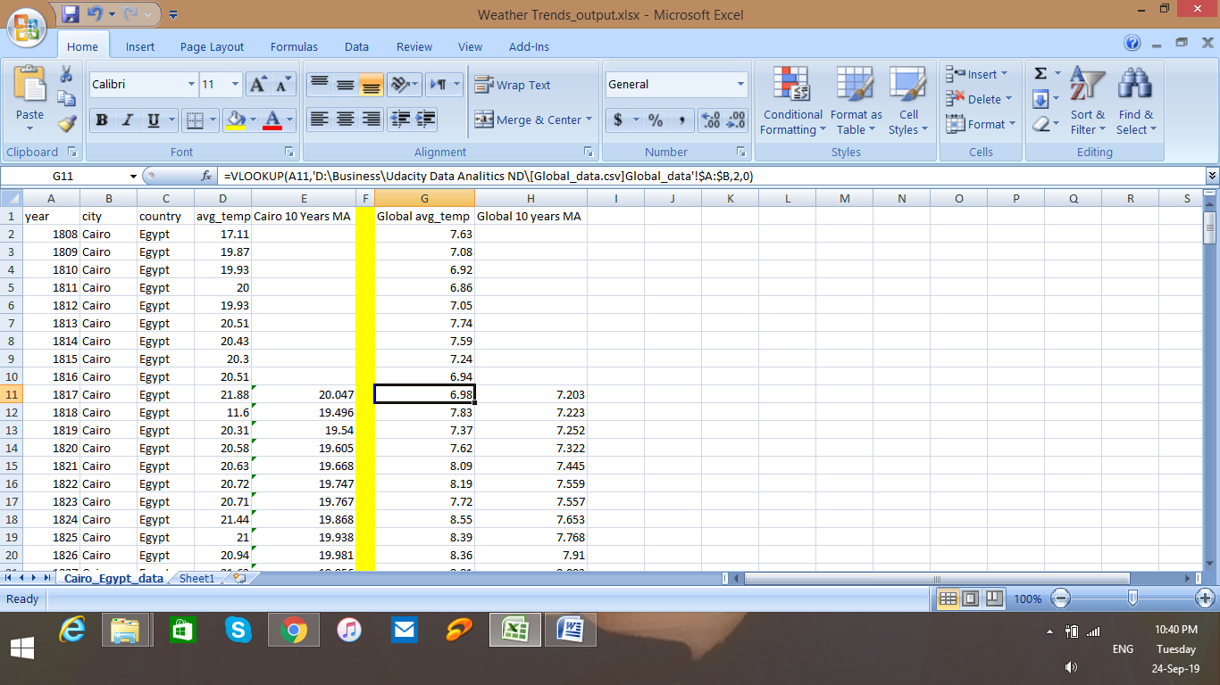

* The calculated 10 years moving average for both Cairo & global are then used copied transposed to other sheet to be able to generate line Chart

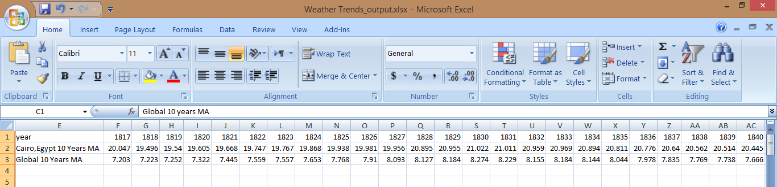

**Line Chart:**

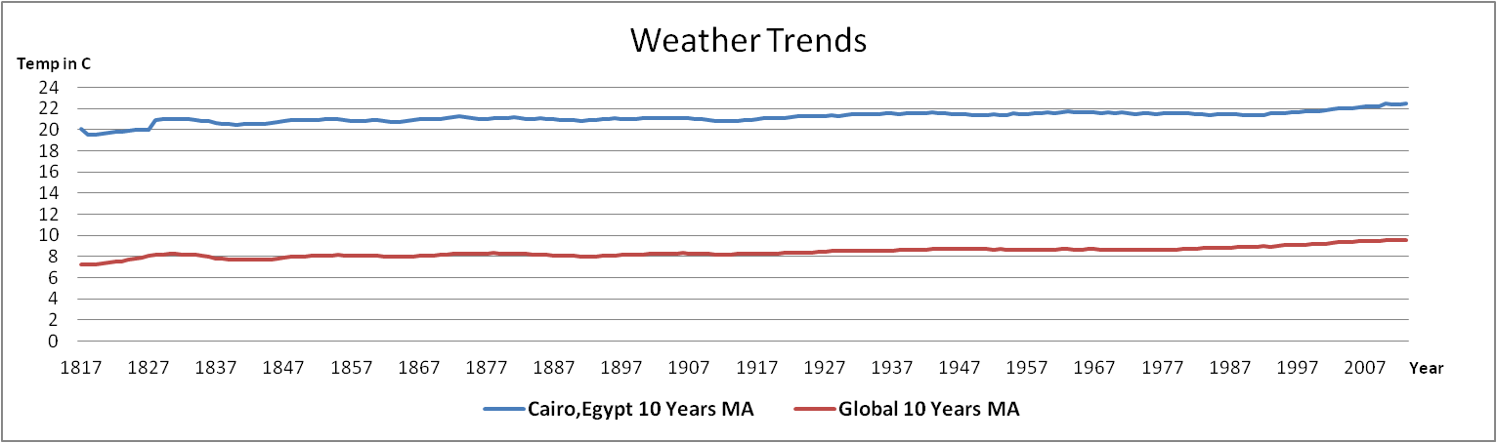

Observations**:**

1. Cairo Temperature vary around 21C while global vary around 8.5C
2. Both of Global and Cairo records have around 2C difference between Max and Min Temperature Recorded (Cairo 20-22 & Global 7.9-9.9)
3. Both witness Temp. Increase around year 1827 & started to decrease again around year 1837 then another increase on 1847
4. Between year 1980 & 1995 Cairo trend was decreasing however the global trend was increasing, then both of them started increasing around year 1997
5. The overall trends tend to be increasing in temperature comparing year 2013 record to year 1817 record